**Ideation Phase**

**Define the Problem Statements**

|  |  |
| --- | --- |
| Date | 14/06/25 |
| Team ID | LTVIP2025TMID58222 |
| Project Name | House-Hunt: Finding-Your-Perfect-Rental--Home |
| Maximum Marks | 2 Marks |

**Customer Problem Statement Template:**

In these problem statement to understand your customer’s point of view, The customer problem statement template helps you focus on what matters to create experience people will love.

A well-articulated customer problem statement allows you and your team to find the ideal Solution for the challenges your customers face. Throughout the process, You’ll also be able to empathize with your customers, which helps you better understand how they perceive your product or service

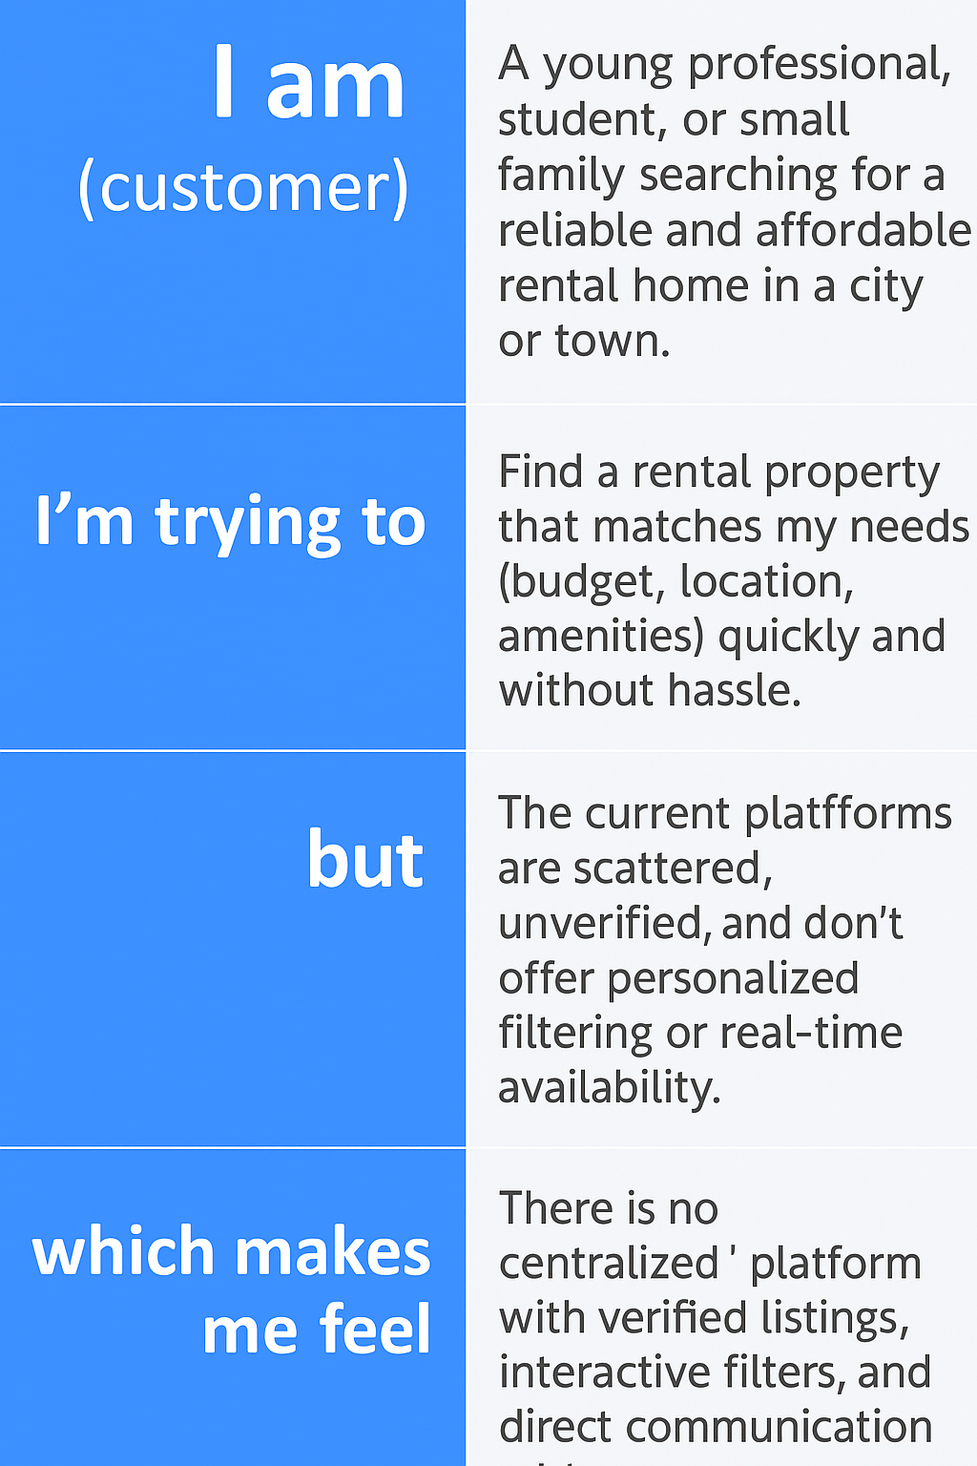

Example: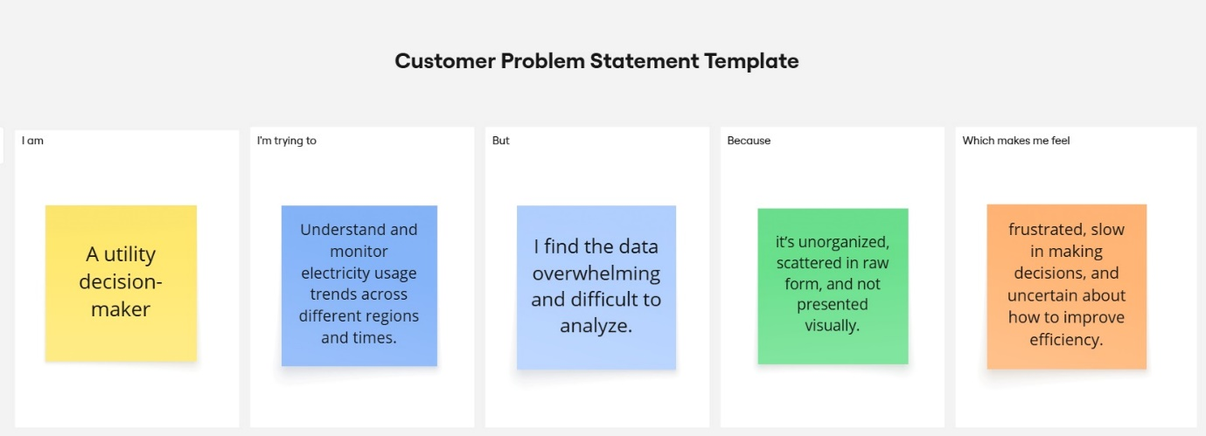

|  |  |  |  |  |  |
| --- | --- | --- | --- | --- | --- |
| **Problem Statement (PS)** | **I am (Customer)** | **I’m trying to** | **But** | **Because** | **Which makes me feel** |
| PS-1 | I am a renter searching for a home in a new city | I'm trying to find a suitable rental property that fits my budget, location, and space needs | But the listings are scattered, outdated, or incomplete | Because there is no unified platform that provides verified, up-to-date, and filtered rental options | Which makes me feel confused, frustrated, and unsure about the credibility of the options available |
| PS-2 | I am a property owner wanting to rent out my home | I'm trying to reach trustworthy tenants quickly and manage my listings efficiently | But I struggle to find a reliable platform where my property gets good visibility | Because current platforms lack tenant verification and communication tools. | Which makes me feel uncertain, delayed in renting out, and worried about potential tenant issues |